A000-US-MN-Kensington Runestone-1362

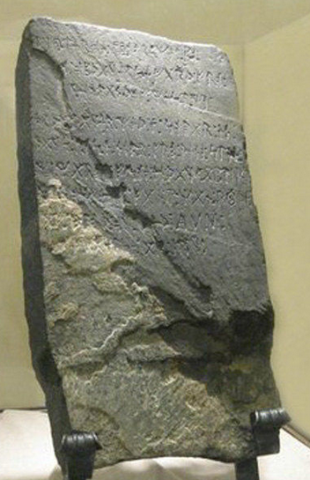

Named for Kensington, Minnesota, but it was found in the rural township of Solem, Douglas County, Minnesota in 1898.

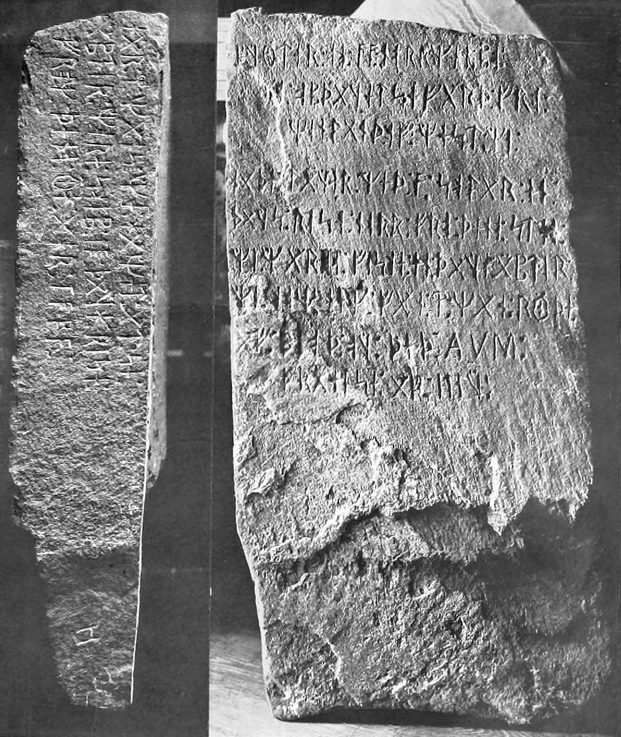  
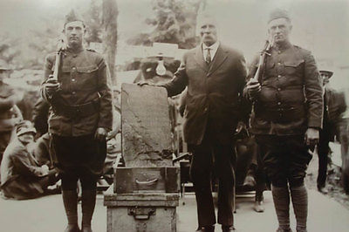  
As the story goes, a Swedish immigrant farmer Olof Ohman and his son found the stone lodged into the roots of a tree they were removing from a field to be plowed. According to the story, the two didn’t even notice the inscription until much later, after Ohman’s son dusted the stone, and dug the dirt out of the engravings with a stick.  
  
The stone itself is a large slab of greywacke, roughly the shape of a tomb stone, that has runic inscriptions on two sides. The inscription tells the story of an ill-fated Norse excursion in the area that would become Minnesota.

"Eight Geats and twenty-two Norwegians on an exploration journey from Vinland to the west. We had camp by two skerries one day's journey north from this stone. We were out to fish one day. After we came home found ten men red of blood and dead. Ave Virgo Maria save us from evil."  
  
"We have ten men by the sea to look after our ships, fourteen days' travel from this island. In the year 1362."